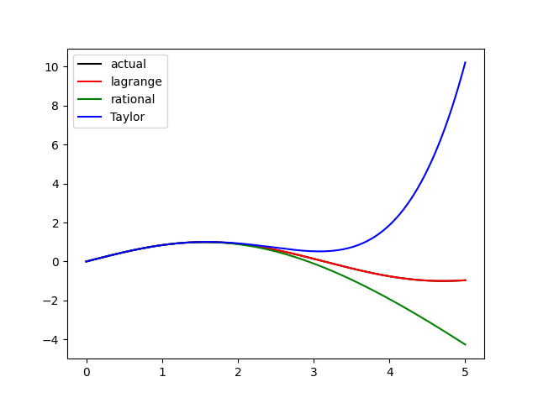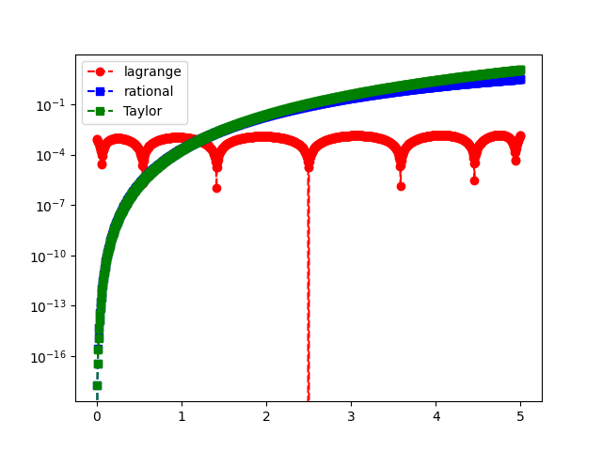1a) Pade Plot Pade Error

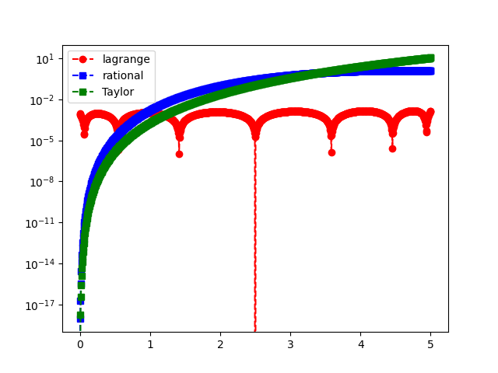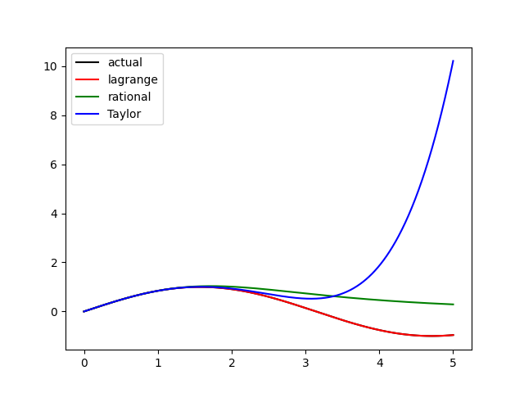1b) Pade Plot Pade Error

